**Objective: Find the best investment platform based on global sales:**

Before I do any processing and plotting, all data has to be cleared out. Any piece of data in the year column that is not number is rejected. Any year value more that 2017 is not valid and removed.

The best one should be among those which have sales in the past few years like 2014-2016. If a platform does not have sales in recent sales, it means that it is out of market and it has no value.

1. **Global**

Here is the plot of all data accumulated:

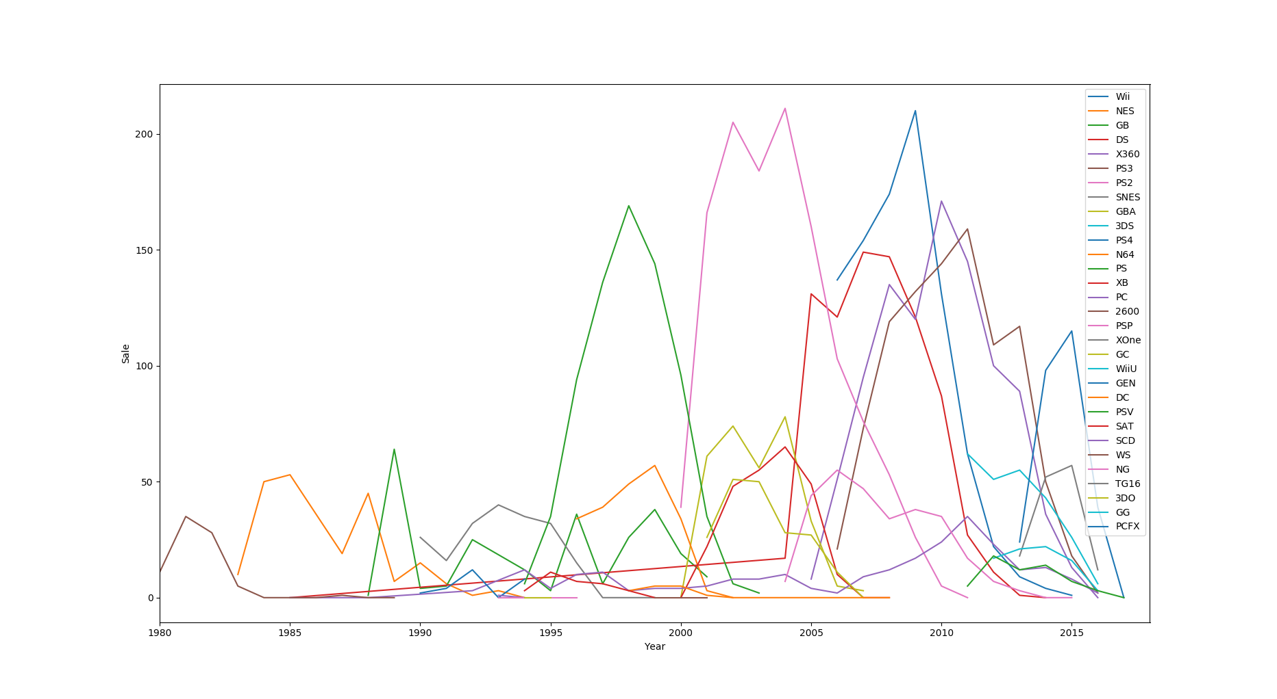

The ones which have sale in recent years are: Wii, DS, X360, PS3, 3DS, PS4, PC, PSP, XOne, WiiU, PSV.

Here is a list of those which have data in recent years.

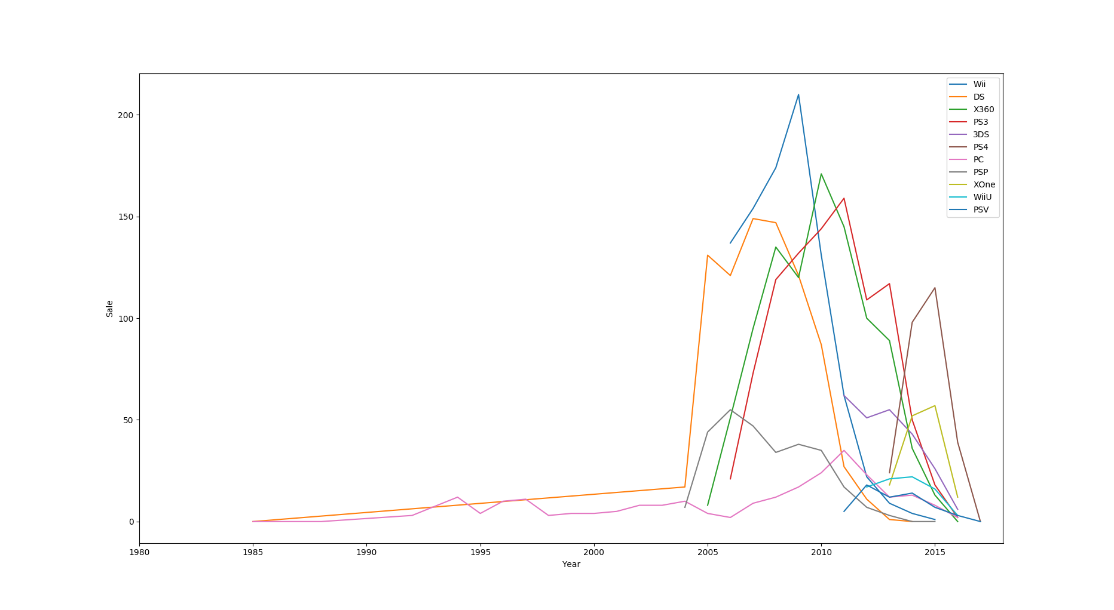

If you look at the chart all of these platforms were in decile in recent years and thus it should not be the parameter you would make decision based on. Instead, I would look at the number of years a platform was in decline. Among those mentioned above I would pick XOne or PS4 as they were in decline only for year 2016, while others were in decline for more than one year.

Between those two I would pick XOne. Although PS4 had larger market in recent years, the decile of XOne is less steep and is probably safer for investment

1. 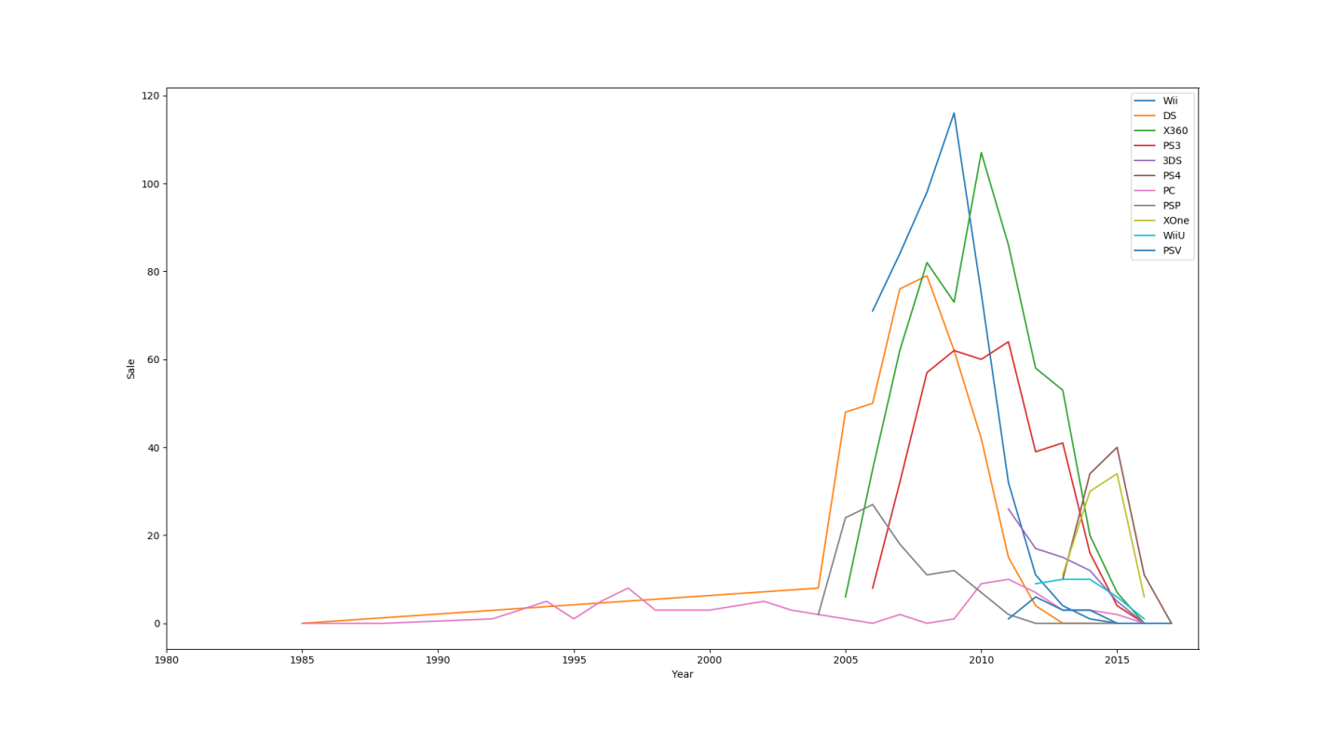**North America**

Using the same method here is the data for the recent years in North America:

North America also shows the same patterns as global data and thus between XOne and PS4 I would still pick XOne because of the same reasons.

1. **Japan**

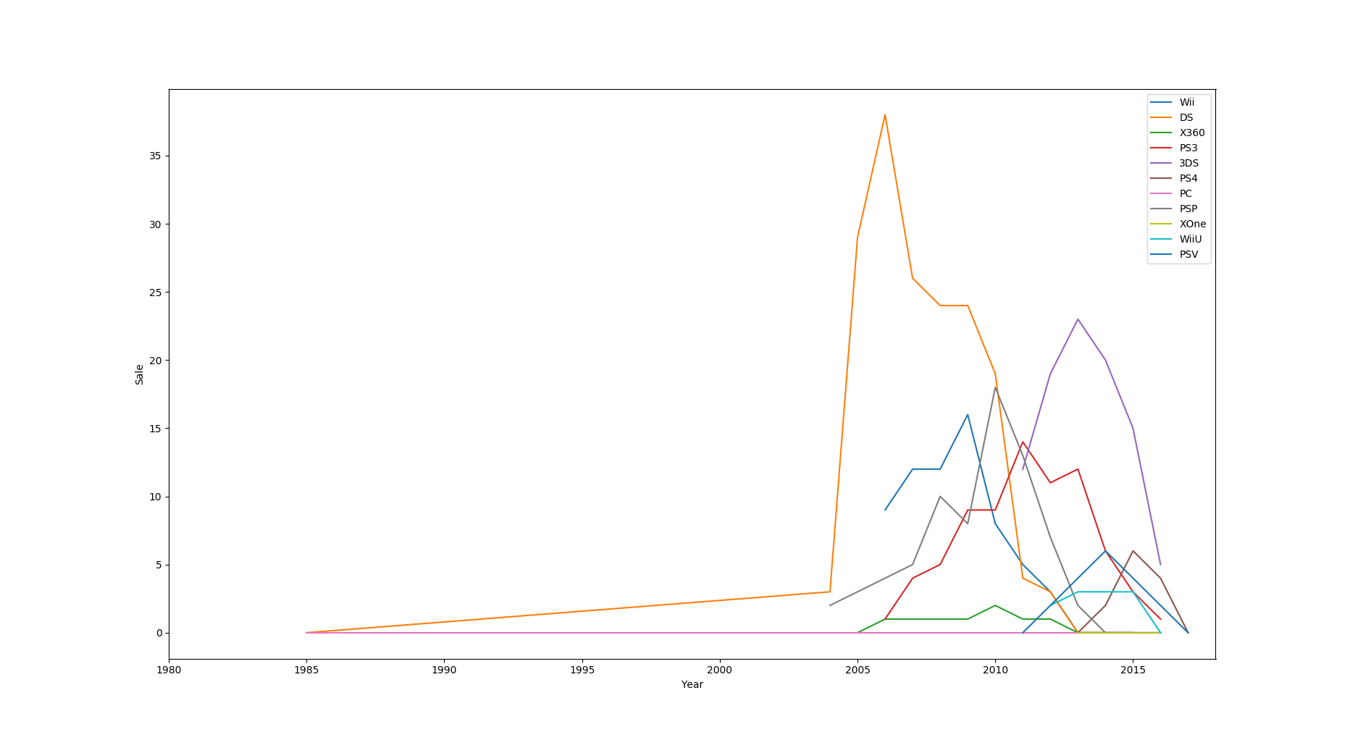

Here is the data for the recent years in Japan:

Interestingly, market in Japan has a different behavior in comparison with North America and global. DS, which is not doing well as all in recent years, had the biggest share of the market in years 2004 to 2008 but has a very steep decline to zero after 2010. Although all platforms were in decline in recent years, like global and NA data, PSV and PS4 are doing better.

Among these two platforms, I prefer to invest in PS4 as its decline is less steep than PSV’s.

1. **EU**

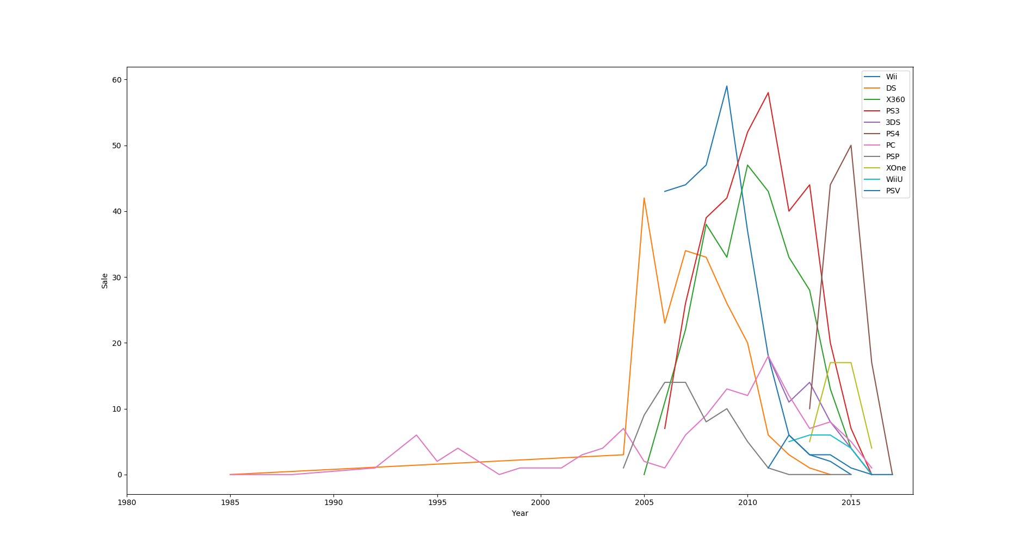

Here is the data for the recent years in the EU:

EU has the same trend of global and North America. Thus, using the same reasoning my choice would be XOne.

1. 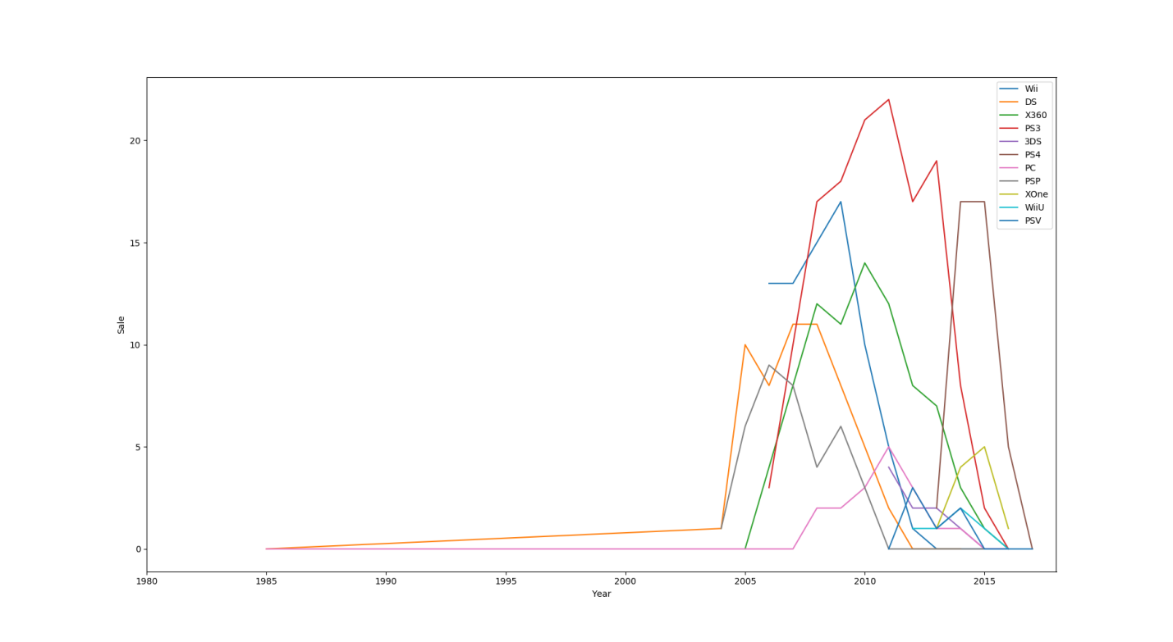**Other**

Here is the data for the recent years in other continents/countries:

Others have the same trend as global and North America. Thus, using the same reasoning my choice would be XOne.

**Python Code**

"""

game prediction project 0

"""

import csv

import matplotlib.pyplot as plt

plat = []

with open('videogamdata.csv', 'rb') as f:

reader = csv.reader(f)

for row in reader:

if row [2] not in plat and row [2]!='Platform':

plat.append(row [2])

print "Company length is: " , len(plat)

print plat

print " "

#platNew = [plat[0], plat[3], plat[4], plat[5], plat[9], plat[10], plat[14], plat[17], plat[18], plat[20], plat[23]] # best platforms in

#for p in platNew:

platNew = []

for p in plat:

year = []

with open('videogamdata.csv', 'rb') as f:

reader = csv.reader(f)

for row in reader:

if row [3] not in year and row [2]==p and row [3]!="N/A" and int(row [3])<=2017:

year.append(row [3])

year.sort()

region_num = 10 #6:NA, 7:EU, 8:jpn, 9:OTH, 10:GLB

sumList = []

sumTemp = 0

if ('2016' in year) or ('2015' in year) or ('2014' in year):

platNew.append(p)

for p in plat:

year = []

with open('videogamdata.csv', 'rb') as f:

reader = csv.reader(f)

for row in reader:

if row [3] not in year and row [2]==p and row [3]!="N/A" and int(row [3])<=2017:

year.append(row [3])

year.sort()

#print ""

#print ""

#print 'Years are: ', year

sumList = []

sumTemp = 0

for y in year:

with open('videogamdata.csv', 'rb') as f:

reader = csv.reader(f)

for row in reader:

if row[3] == y and row[2]==p:

sumTemp = sumTemp + float(row[region_num])

sumList.append(sumTemp)

sumTemp = 0

#print 'Sales are: ', sumList

plt.xlim(1980, 2018) # set the xlim to xmin, xmax

if ('2016' in year) or ('2015' in year) or ('2014' in year):

stri1 = [int(e) for e in year]

stri2 = [int(e) for e in sumList]

plt.plot(stri1, stri2)

plt.legend(platNew)

#plt.legend(platNew)

#plt.xlim(1980, 2018) # set the xlim to xmin, xmax

plt.xlabel('Year')

plt.ylabel('Sale')

plt.show()